The Weather Room
Introduction
Northern Ireland is no stranger to the rain. Our rainy weather is often a conversation opener among locals and visitors alike; however, the physical act of recording and monitoring weather occurs out of public sight, in weather stations inaccessible to the public.
Weather forecasts are readily available through many forms of digital media. Could facilitating the opportunity to physically observe and record the weather increase public knowledge and appreciation for weather and climate change, drawing attention to the importance of designing for the weather and accommodating water in our built environment?
Precedents
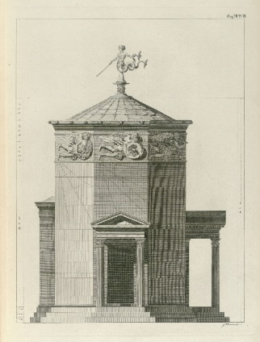
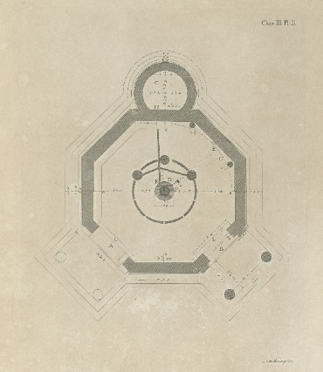

Meteorological apparatus has historically featured in public spaces of towns and cities. Often considered to be the first meteorological station, Horologian of Andronikos Kyrrhestes (also known as the Tower of the Winds) was constructed in the 1st century BC. The ancient structure, octagonal in form, included sundials, a weather vane and a water-clock, powered by a large well under the Acropolis and providing a means for reading the time on cloudy days when sundials were ineffective. The eight sides represent the eight Greek gods of the wind, also representative of the cardinal and ordinal points of a compass.

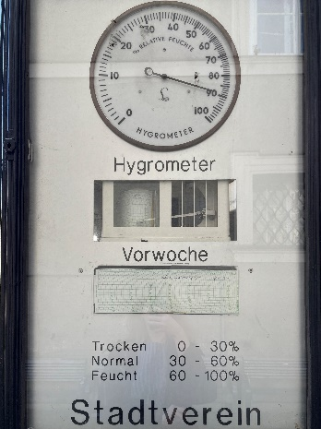
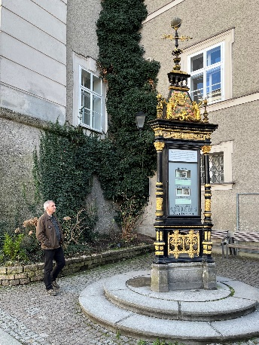
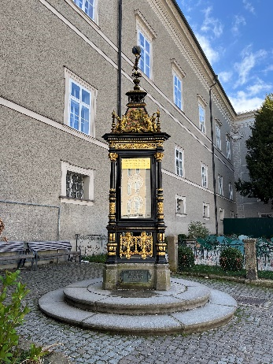
In the 19th century, Meteorological pillars were installed in cities, providing the function of displaying live weather information in public locations whilst also serving as a public monument. An example is Salzburg’s Wettersäule. The ornate weather instrument is located by Residenzplatz, a significant public plaza in the city and features measuring devices for recording the temperature, barometric pressure and humidity in Salzburg. Its intricate design celebrates the science behind weather recording, and its location embeds it into the everyday life of the city.

A contemporary example of a public weather station is Flood House by Matthew Butler.
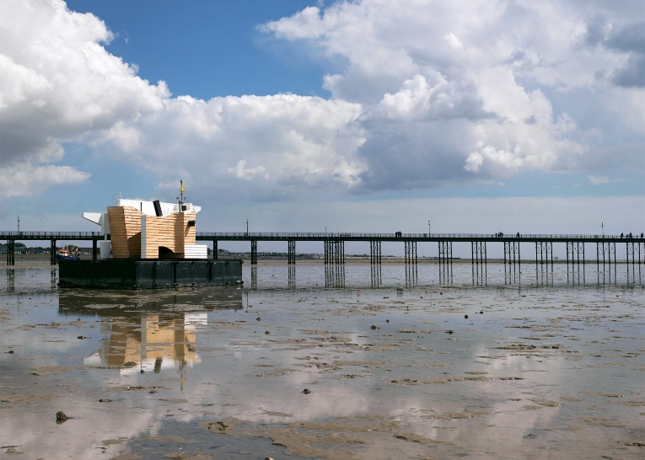
Initially, the floating mobile structure was moored at various locations on the Thames Estuary over a four-week period in 2016. Concerned with climate change, the project served as an exploration for ways of living with flooding in the UK, an architecture responsive to tidal patterns and also housed a laboratory to record local weather conditions. The structure was used to facilitate an interdisciplinary public art and education programme aligned with its movement along the estuary before it was installed at Brunswick and Columbia Wharf between 2016-2019.

With the weather having a direct impact on our water bodies and water infrastructure, enhancing locals relationship to water through visual indicators such as tide levels would provide a visual means to monitor and understand tidal patterns, raising awareness of the potential impact of sea, river and surface water flooding on local towns and cities and the increased potential for periods of both flooding and drought due to climate change. Tidal gauges are a historical method of measuring changing levels, often used for OS surveys.
Proposal
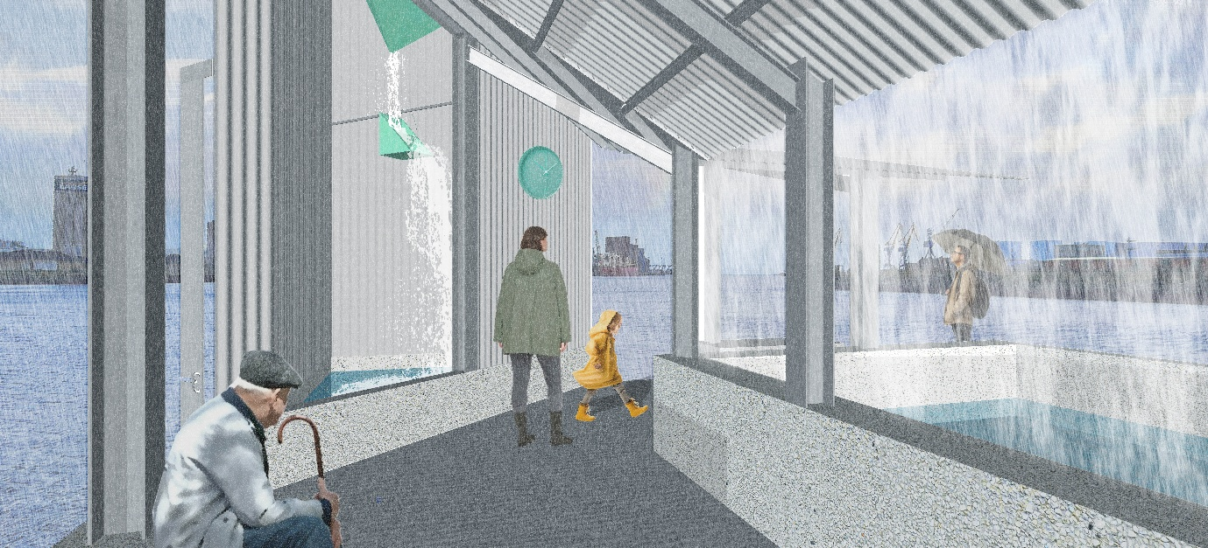
The waterfront pavilion uses water as a design element to create a sensory experience and deepen conversations about the weather in Northern Ireland’s urban spaces.
The roof plan and elements of the pavilion are arranged and orientated to symbolise the ordinal points of a compass, with the northernmost formed by a double height space containing a sculptural funnel and ‘tipping bucket’ to operate as a rainwater gauge. A tidal gauge will be connected to this northern point to allow tidal patterns to be observed. The inclusion of these sculptural instruments encourages public engagement in observing and discussing climate impacts. A weathervane is also proposed at the northernmost point, and during design development, the incorporation of other weather recording vessels would be explored.
The roof, composed of surfaces angled at varying degrees, manipulates the rate of water flow into a collection pool, highlighting how architecture can control the elements. By integrating weather phenomena into the built environment, the pavilion becomes a destination for reflection and interaction, encouraging awareness of environmental change and the role of design.

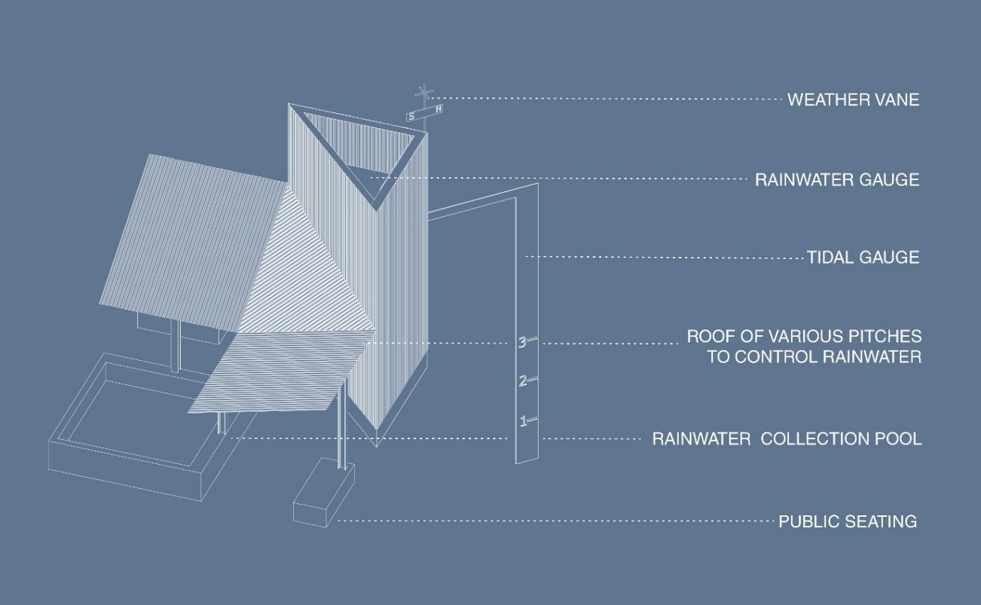
In dry weather, stored rainwater could be pumped to the ridge of the structures, where gravity will pull it across the pitched forms down to the storage tanks in a cycle, emphasising the cyclical nature of the element at a micro scale and its potential to be reused through more practical means in the built environment.
Acknowledging budget constraints, it is proposed that the lightweight structure uses a limited quantity of ‘off the shelf’ structural steel. The roof form and cladding of the rainwater gauge are suggested in corrugated metal sheets with grooves symbolic of channels for directing water and creating a reflective surface to further integrate the natural elements into the space.
There is no fixed location proposed for the pavilion, but it would ideally be situated by a water body. During design development, the ability to dismantle and reassemble elements would be further explored in consideration of the lifecycle and sustainability of the design. The ability to dismantle and reassemble the pavilion would also increase the potential for it to be installed across Northern Ireland’s towns and cities to encourage access and inclusion.
Whilst exposed to the elements, the pavilion can be used as an outdoor classroom, hosting school classes and other user groups by offering a means to observe the weather in a poetic manner. The temporary nature of the space will offer the opportunity for multiple stakeholders to propose programme activities for the duration of its installation and encourage variety in discussions and visitors to the space.
The proposal to include weather instruments could potentially encourage involvement of a range of local university departments that may be interested in assisting with further research and development.
